Hello !
First of all i want to thank you for buying my product! if u find any issues or have any sugestion Please contact me at Wao3dStudio@gmail.com
V1.2
The new update adds support for URP and HDRP.
All textures have been modified and added Specular and Ambient occlussion maps .
Added original blender file .
Added new Flock script .
Removed the particles follow from the older versions {you can still get it by downloading the older version}
One new idle animation.
New Shaders , iridescence effect in URP and HDRP
For the new flock script , crate an empty object in the scene
select the empty object and add component Flock
select your prefab mesh and add component Flock unit
select the empty game object and then drag and drop the prefab in to Flock unit prefab.

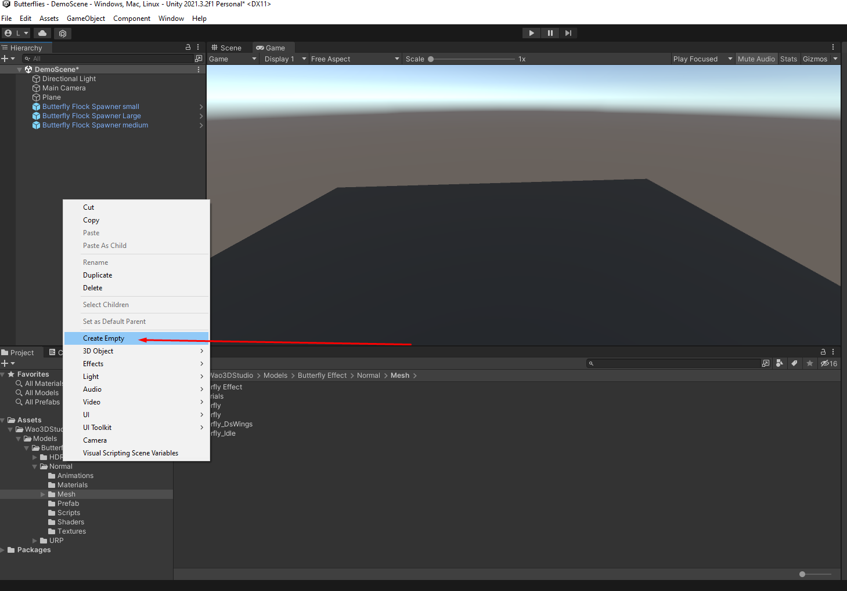
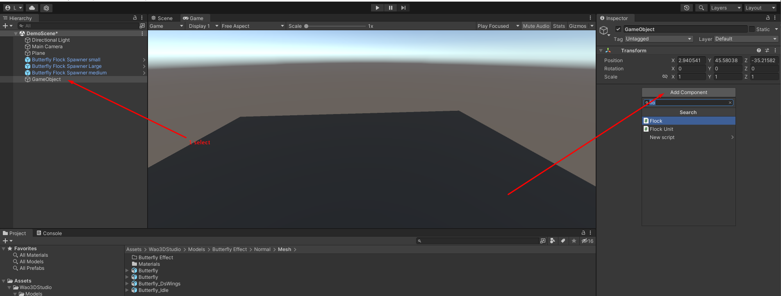

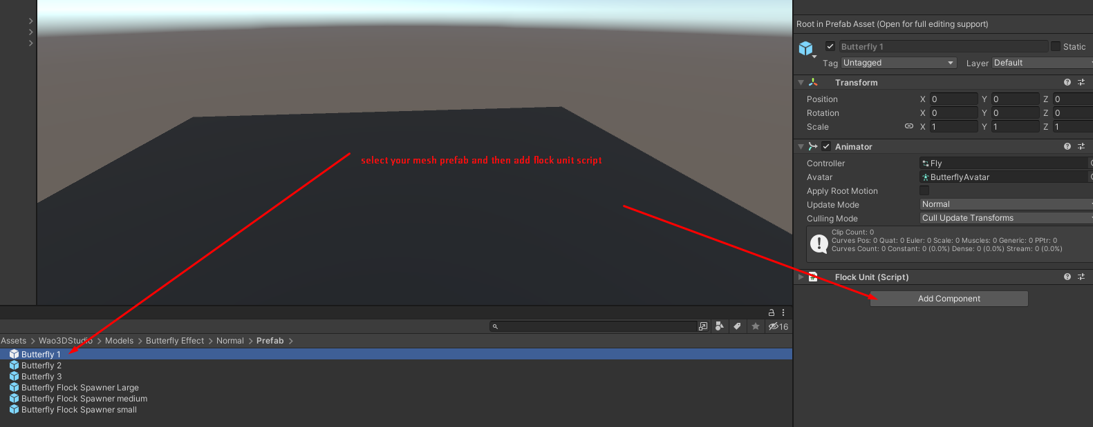
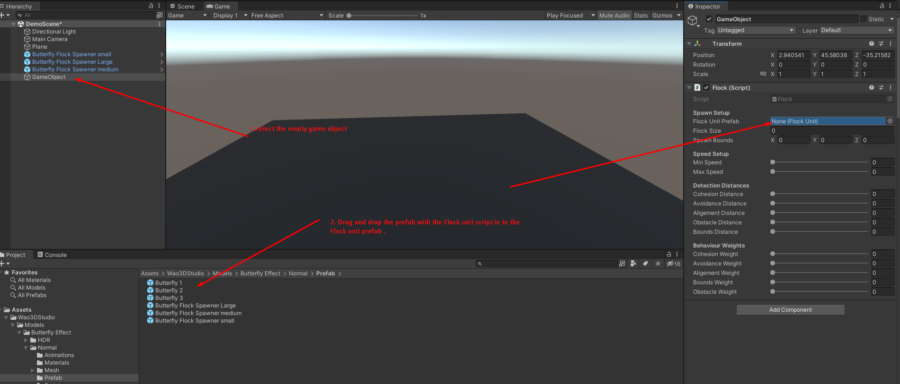
Use these options for configuraton.
The flock unit
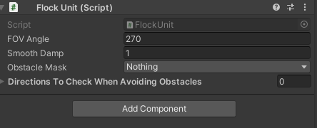

Flock script spawner (the empty game object)

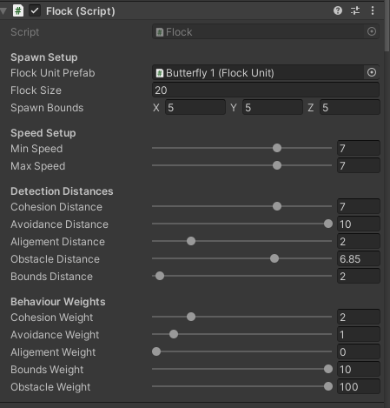

Change flock size for the number of butterflies
play with speed and the discances to change the behavior of the butterflies.
Ejjoy!
V1.1
*I have removed the high poly butterflies since they have no animations and i don’t provide any updates and improvements for them, they are still available to download with any unity lower versions.
*There are 2 tipes of the butterfly model , normal and the DS version that comes for double sided wings , that comes useful in VR experience.
*In this update i have worked on a special shader that combines the RGB color to achive diferent butterflies colors (someone asked for yellow butterflies so i decided to make this shader , this way you can make them yellow, green blue, red, etc...)
*Removed the base model mesh and added new one with new animations , butterflies have now 4 animations - Take flight, fly , land, Idle Landed.
*And finely something that i was looking to implement a long time ago , and this was possible thanks to Satwant Singh for making this wonderful C# Flock Script , you can see his work at https://www.youtube.com/user/sskenth or @satwantsk .
To use the script just create an empty object in your scene and add the Global Flock Script to it , in the script you need to select one butterfly prefab to be spawn, now add the Flock Script to the prefab butterfly that you selected in the Global Flock.

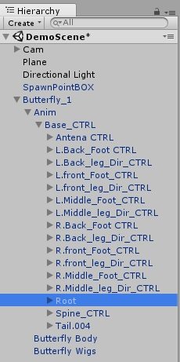
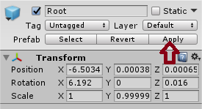
To add the Spark particles to your butterflies open the butterflie hierarchy -Anim\Base_CTRL\Root drag and drop the spark particle in the Root now apply and save the butterflie prefab .

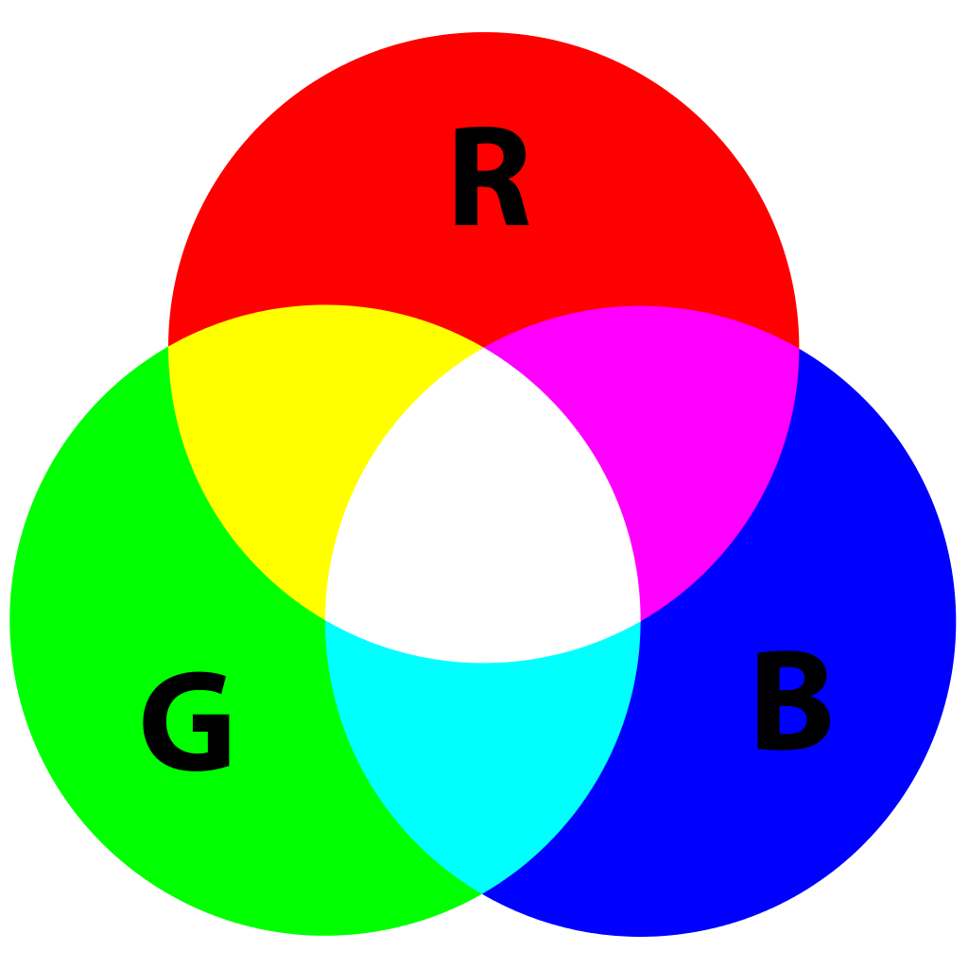
About the Shader.
The shader combines the RGB Colors from the base Difuse texture to create diferent colors

How it works.
Just activate the boolean on-off , so the effect take place, and play with the colors.

